This document explains how the height of a slice is computed. Slices vary in height so that the thinner slices are closer to the compression surface.

Compute the height of general section solver slices

The height of each slice will get progressively larger (or smaller) over the depth of the section. The slices heights are such that the height of the last slice is a multiple of the height of the first slice. The slice heights vary linearly.

Let
H = overall height of section
N = number of slices
g = slice growth factor (0 to < 1, slices gets smaller, > 1, slice gets larger, =1, all slices same height)

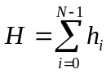
Where
h_{i} = height of the i^{th} slice

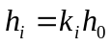
h₀ = height of the first slice
k_{i} = slice height multiplier for the i^{th} slice

